Aryan Aziz

Assignment 4 Questions

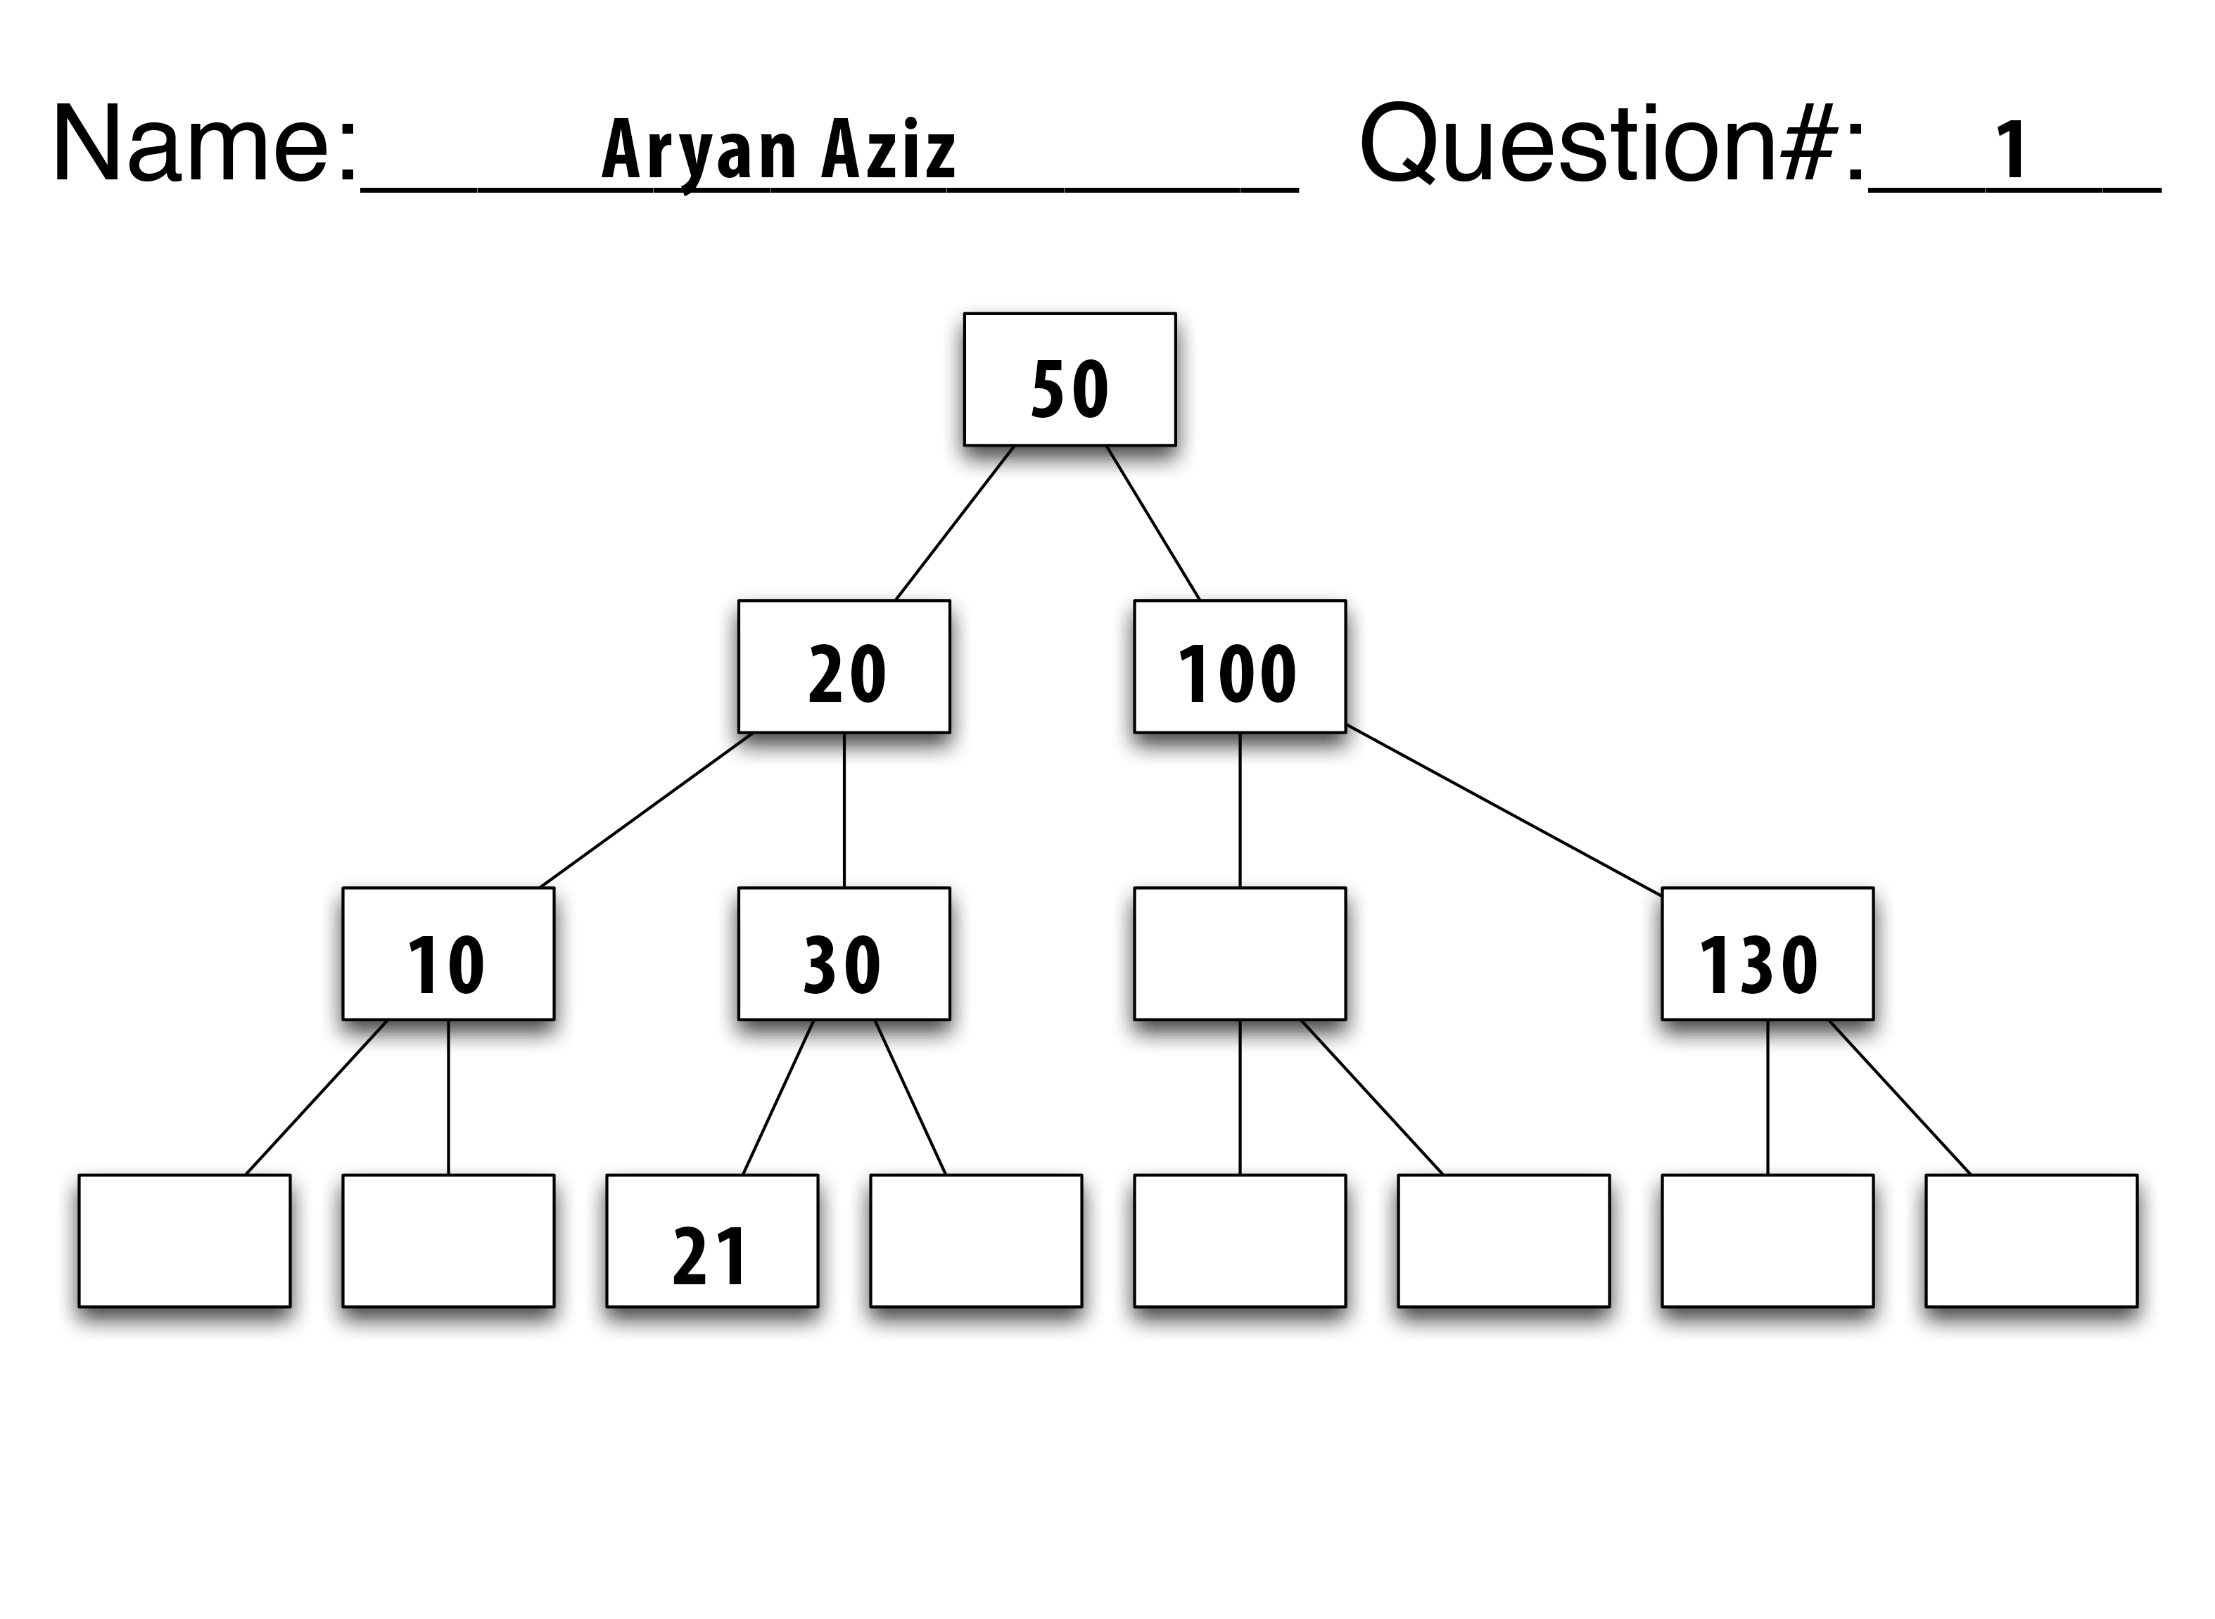

2. If you place 1-7 in order into a binary search tree, you will end with a long chain as each number down the chain will be placed as the new right node of the number before it.

Instead, your order should be: 4, 3, 5, 2, 6, 1, 7

Or: 4, 3, 2, 1, 5, 6, 7

